[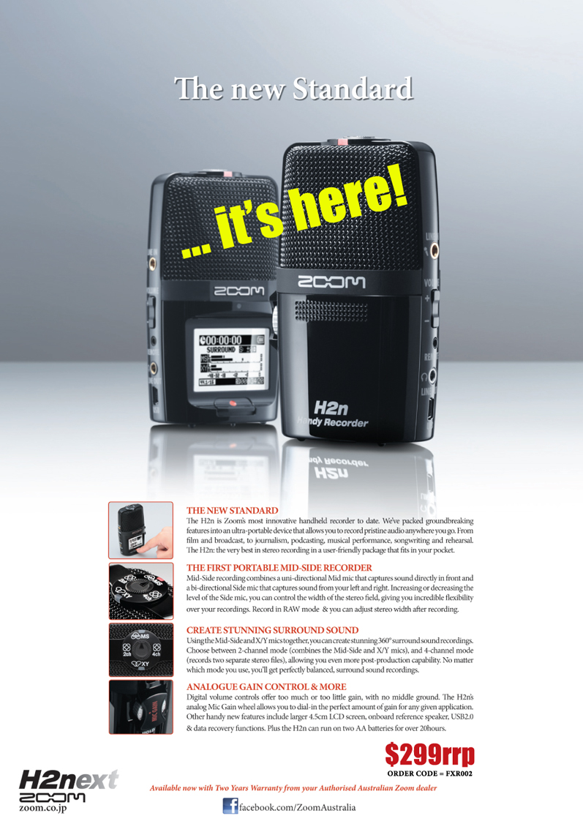](http://www.dynamicmusic.com.au/ProductDetails.asp?CatID=12&SubCatID=294&ProdCode=FXR002)