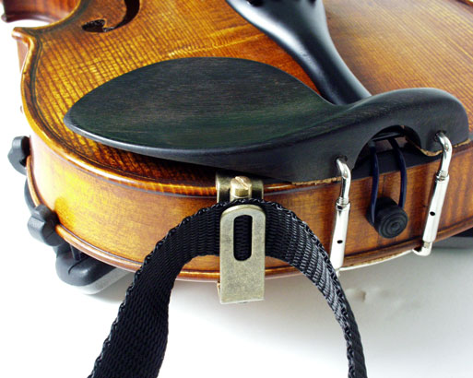


Students & beginners:
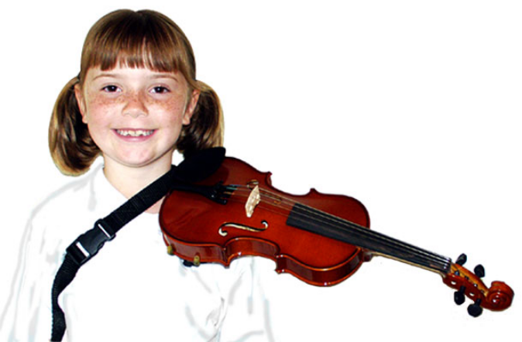

Great for
use as a
teaching aid.

The violin is held independently allowing total concentration on
fingering & bowing, creating the ideal playing position.

Advanced students & professionals:

SUITS:

4/4 - 1/16 violin

& up to

151/2” viola
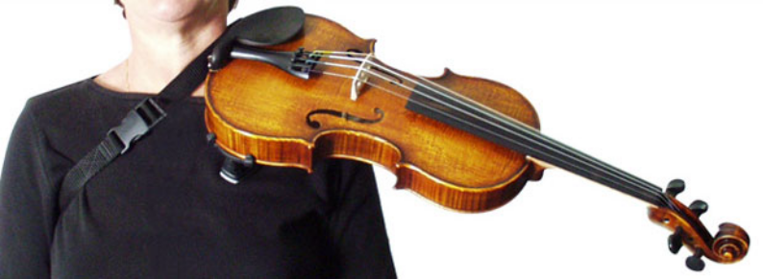
Holds the instrument firmly in place with no need to apply pressure on the chinrest, avoiding strain & tension associated with long practice sessions & playing hours.

Available world-wide from:
Merrylands Music
231 Pitt St, Merrylands NSW 2160, Australia
www.merrylandsmusic.com.au
shop@merrylandsmusic.com.au

